|  |  |  |  |  |  |  |  |
| --- | --- | --- | --- | --- | --- | --- | --- |
| **DONGGUAN YOUAI MEDICAL SUPPLIES CO., LTD** | | | | | | | |
| **ADD:149-1 QINGLONG ROAD, HUANGJIANG TOWN,** | | | | | | | |
| **DONGGUAN CITY,GUANGDONGPROVINCE,CHINA** | | | | | | | |
|  |  |  |  |  |  |  |  |
| **COMMERCIAL INVOICE** | | | | | | | |
|  |  |  |  |  | **DATE: MAY.26/2020** | | |
| **TO** |  |  |  |  | **INV.NO. WT202871** | | |
| **SHABIYA M NAJAB TRADING EST** | |  |  |  |  |  |  |
| **PO BOX 3859,RIYADH 11481** | |  |  |  |  |  |  |
| **KINGDOM OF SAUDI ARABIA** | |  |  |  |  |  |  |
| **TEL: 009663221622** | |  |  |  |  |  |  |
|  |  |  |  |  |  |  |  |
| **ITEM/NO** | **DESCRIPTION** | **QTY** | **UNIT** | **HS CODE** | **PACKING** | **UNIT PRICE** | **TOTAL** |
| **(US$)** | **(US$)** |
| **1** | **DISPOSABLE FACE MASK** | **1000000** | **PCS** | **6307900090** | **50*50PCS** | **0.081** | **81000** |
|  |  |  |  |  |  | **TOTAL US$** | **81000** |
| **TOTAL: EIGHTY ONE THOUSAND (81,000USD) USD ONLY** | | | | | | | |

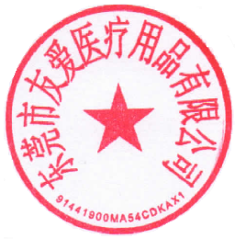

|  |
| --- |
| **Delivery Terms: C/F KSA** |
| **Country Of Origin: Republic Of China** |
| **Name And Address Of Manufacturer:-** |
| **DONGGUAN YOUAI MEDICAL SUPPLIES CO., LTD** |
| **149-1 QINGLONG ROAD, HUANGJIANG TOWN,** |
| **DONGGUAN CITY, GUANGDONGPROVINCE, CHINA** |

